|  |  |  |  |
| --- | --- | --- | --- |
| **1. Project Summary** | | | |
| **Start Date** | 04/30/2018 | **Finish Date** | 05/18/2018 |
| **Project Duration** | 5 Days(Not Including Weekends), 180 hrs total, 60 hrs per person | | |

## 

|  |
| --- |
| **2. Project Goal** |
| * Creating a base to build and grow the company * Upgrading all of their old technology to technology that is up to the requirements they need to succeed in the business * Making sure that all the new technology is secure and safe * Making sure that only the employees of the company can have access |

|  |
| --- |
| 3. Project Deliverables |
| Employees (8): 2 Office Employees and 6 Mobile workers  **Administrative Manager:**  Application that will be use in the PC.  - spreadsheet  - database  - email provided by ISP  *\*The current PC tower is enough for the manager’s needs.*  **Film and Graphics Production Editor (one of the partners):**  - Special editing software that uses *very high-resolution graphics* and requires at least 16GB of memory. –Video Capture Interface Board that uses PCIex16 slot.  - PC must have Windows 10  - email provided by ISP  **Film Crew (6 employees; Mobile workers):**  Ø 2 Production Assistants  Ø 2 camera people  Ø Production Manager (one of the partners)  Ø Film Director  - They all need to connect to the main office from anywhere  - Large hard drive  - Need to connect to internal network    Private laser printer in the manager’s office  A combination copier/printer and high-resolution scanner for all employees |

|  |
| --- |
| 4. Comments (If any) |
| **Budget ($35 000.00)**  Graphics Computer  $5 974.98  Printer  $749.99  Laptop  $16 199.94($2 699.99 * 6)  Cisco Hardware  $2 191.73  Server Plus Backup Power Supply  $1 695.94  Total  **$26 212.59 + $5 400 (Labour)**  **$31 612.59** |

|  |  |  |  |
| --- | --- | --- | --- |
| 5. Document Signatures | | | |
| **Name** | **Description** | **Signature** | **Date** |
| Susan Roberts  Administrative Manager | By signing this document, I acknowledge that I have received all the stated deliverables at the agreed to quality levels. |  |  |
| Scott Patterson  Project Manager | By signing this document, I acknowledge that I have delivered all the stated deliverables at the agreed to quality levels. |  |  |

Topology Maps(Physical and Logical):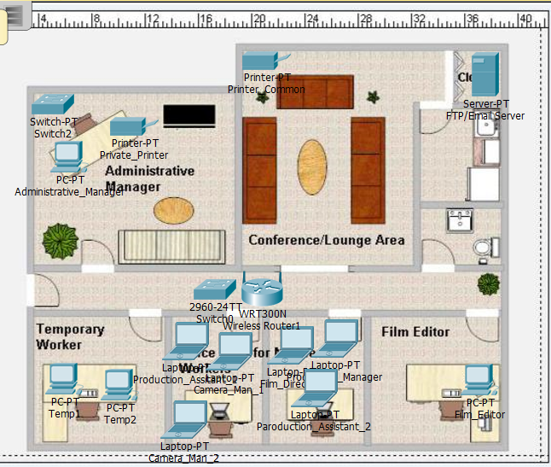

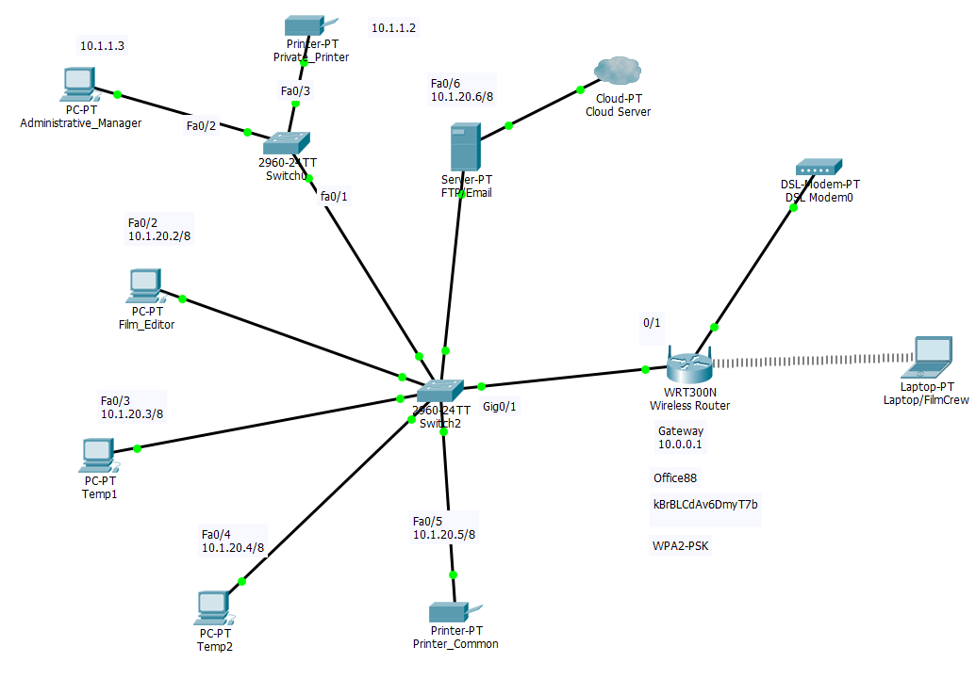

**INSTALLATION CHECKLIST**

|  |  |
| --- | --- |
| Customer Site PC Installation Checklist | |
| Computer Device | Installed |
| Desktop PC - Administrative Manager |  |
| Desktop PC – Film Editor |  |
| Desktop PC – Temporary Worker 1 |  |
| Desktop PC – Temporary Worker 2 |  |

|  |  |  |
| --- | --- | --- |
| Network Configuration and Installation Checklist | | |
| Device | Installed | Configured |
| Server/Cloud |  |  |
| Main Switch |  |  |
| Administrative Manager Switch |  |  |
| Main Router |  |  |
| DSL Modem |  |  |

|  |  |
| --- | --- |
| Security Checklist | |
| Measures | Completed and Installed |
| Firewall |  |
| Antivirus |  |
| Software Patches and Updates |  |
| Antispyware |  |
| Spam Filter |  |
| Popup Blocker |  |
| User Authentication |  |